

Assignment Cover Sheet

To be completed electronically by the student and submitted with each piece of work. Please upload this completed cover sheet via Turnitin.

Assignment Title: Introduction to Programming
Tutor: Ms. Muniba Murtaza
Student Number: 01250507
Date of Submission: 13/01/2026
Details of your submission: Summative assessment 2
For an online submission, please enter the URL of where your project files can be accessed (e.g. Google Drive). If a physical artefact, please provide further details on how this project has been submitted to tutors.
- PPT slides for both assessment: (you will attach with this same document)

- Word doc: (you will attach with this same document)

- GitHub link 1 (Assessment 1): https://github.com/ahmed101707/introduction-to-Programming.git

- GitHub link 2 (Assessment 2): https://github.com/ahmed101707/introduction-to-Programming-assessment-2-.git

In submitting this assignment, I am confirming that I have read and understood the regulations for assessment, and I am aware of the seriousness with which the Institute regards unfair practice. Please see the institute’s Unfair Practice Policy for details.

Signed: Date:
Brief
This project focuses on creating and executing a console-based Vending Machine application using Python. The program enables users to choose items, input money, get change, and receive feedback messages. The final application code is available on GitHub at: GitHub Repository: https://github.com/ahmed101707/introduction-to-Programming-assessment-2-.git

Specification.
The vending machine program has the following features.
• A list of snacks and drinks on the console.
• Every object has a unique code.
• · Allows the user to enter item codes.
• Handles money, and can accept different amounts as input.
• The machine gives back the correct change.
• The item you selected will be dispensed message.
• Show message of change.
• It possesses a system for managing stock.
• Products that are classified with other ones.
• Able to buy multiple things at once.
• Functions help to maintain the good structure of a program
• Incorporates checks to limit errors during runtime.

Flow Chart.
The vending machine software flowchart depicts the logical process flow. It starts by showing the menu, taking user choice and validating the choice made. It deals with such payment, product delivery and return of change. The user can make another purchase or choose not to.

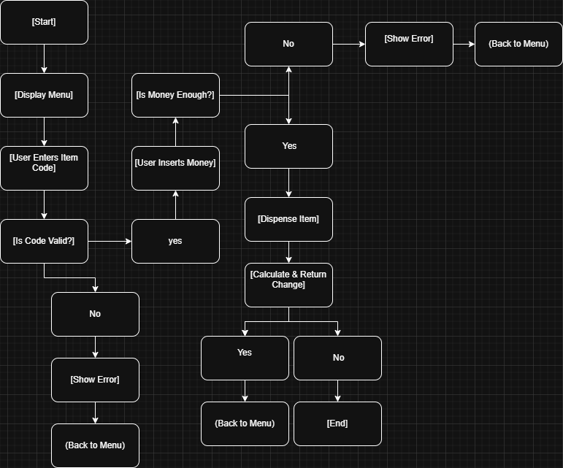

Technical Description
The Vending Machine program is made using Python and works like an actual vending machine. It allows users to choose what they want to buy, see the available items, pay money, and get their item along with any change. This program shows how basic programming ideas can be used to build a system which is useful.
All the items in the vending machine are stored in a dictionary. Each item has one unique code, like A1 or B2, which helps in identifying the object, every code is linked to another small dictionary that contains the item’s name, category, price, and how many of that item is left in the stock. This setup makes the program easy to find the specific item if available in the stock.
The program gets input from the user by the input function, { input() }. The user will type the item code into it and the amount of money they are going to pay, the program will check this input using the (if) function and (while) statements. If the user does not enter the right amount or if the amount given by the user is less than the amount of the object displayed, the screen will show an error and the object wont be given to the user, but if the user gives more money then there’s a calculation done and the change is given back to the user, The change is rounded to two decimal places and shown to the user.
The program also allows users to buy more than one item, the program asks the user if they want to buy another item, If they say yes, the menu is shown again and the process repeats. If they say no, the program ends with a friendly message.
Stock is also managed in the program, so when an item is brought, the number of that item in the stock is reduced by 1, if that item reaches 0 stock then it cant be bought anymore by the user until restocked, this makes it look more realistic and shows how well the program is made.

Critical Reflection
Not only does this vending machine project demonstrate how programming can solve real-world problems with automation and user interaction, but it also provides evidence that user interfaces can be made similar to real-world systems. This vending machine illustrates how a user can select a product, pay for that product, and receive that product in a step-by-step manner. With the example of this vending machine, we can see how software can be used to mimic real-world processes and therefore helps to understand the concept of making decisions and dealing with conditions in software programming. The choice of simple menus and prompts to guide users through the checkout process is essential to the success of any application. In addition, the vending machine's ability to perform basic tasks, determine whether or not the product is out of stock and whether or not the user has enough money to purchase the item are two examples of control flow and error handling, which are critical workmanship components in programming. Ultimately, it allows for improved logic and critical thinking skills while operating the vending machine and will only improve as the user continues to practice and refine those skills. The system could easily add new features, The system is able to easily integrate new function capabilities such as providing customers with accurate change at checkout, Providing customers with the ability to purchase multiple items in one transaction, and allowing stores to track their inventory in real-time. The user interface of the vending machine could also have a more visually appealing look. Currently the user interface is text-based, but it could use Graphical User Interface (GUI). Also, the vending machine can provide clearer error messages to help the user navigate through the process of buying a product more efficiently. To upgrade the system as described above would require more advanced programming skills. Learning about data structures such as arrays, lists, or dictionaries will improve the efficiency of managing inventory levels. Also, an understanding of Object-Oriented programming will allow the vending machine to be more modularized and scalable. Finally, to provide the user a more pleasant experience and more efficient functionality of the vending machine, it would be beneficial to obtain experience using GUI libraries along with the advanced input validation techniques for validating input. There are many areas where learning and improvement can be made in the programming aspect.

